Hardware/ Component Lists :

|  |  |  |
| --- | --- | --- |
| Name | Estimate Price | Function |
| Arduino UNO | RM 50 – RM 100 | Controller - Processing, Logic, AT Commands |
| SIM900A GSM/GPRS Module | RM 50 – RM 100 | GSM Module – Connect with 2G Mobile Network |
| Prepaid Sim Card (Active) | RM 10 + Monthly bills | Sending Message to Network |
| Power Adapter/ Supply 5V 2A | RM 20 | Provide power to board |
| Jumper Wires | RM 1 | Connecting wires between modules |
| USB Cable Type A/B | RM 10 | To connect Arduino board with PC |
| Micro Lever Switch | RM 1 | Sensor button |
| Arduino IDE | Free | Coding environment (download at Arduino website) |

Connections:

|  |  |  |  |
| --- | --- | --- | --- |
| Arduino | SIM900A GSM | Lever Switch | Function |
| Pin 7 | **TXD** |  | Transmit Data [Serial Port] |
| Pin 8 | **RXD** |  | Receive Data [Serial Port] |
| GND | **GND** |  | Grounding |
| 5V |  | **C (Common Pin)** | Common terminal |
| Pin 2 |  | **NO (Normally Open)** | On indicator 5V – HIGH |
| GND |  | **NC (Normally Close)** | Safety for 0V – LOW,  (better with 10K resistor in series connected) |
| - | 5V 2A Power Source |  | Power the board |
| USB A/B | - |  | Code AT Commands |

Change terminal connection (except Common - yellow) for opposite press or release input detection.

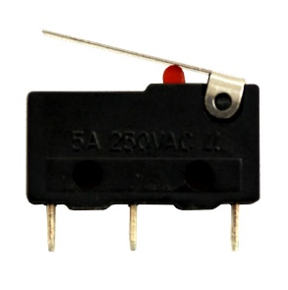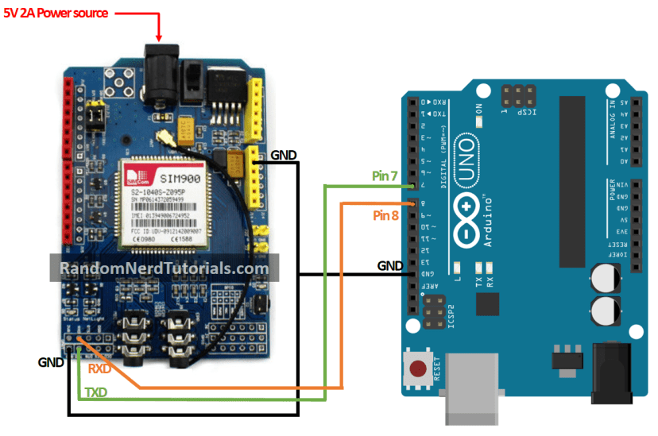

**NC**

**NO**

**C**

**PRESSED** (sent msg)

**OPEN** (standby)

USB

Antenna

Coding (Using Arduino IDE)

1. Install Arduino IDE inside PC.
2. Open “gsm_send_msg_by_HakamRaza.ino” file inside Arduino software code IDE. Paste code here.

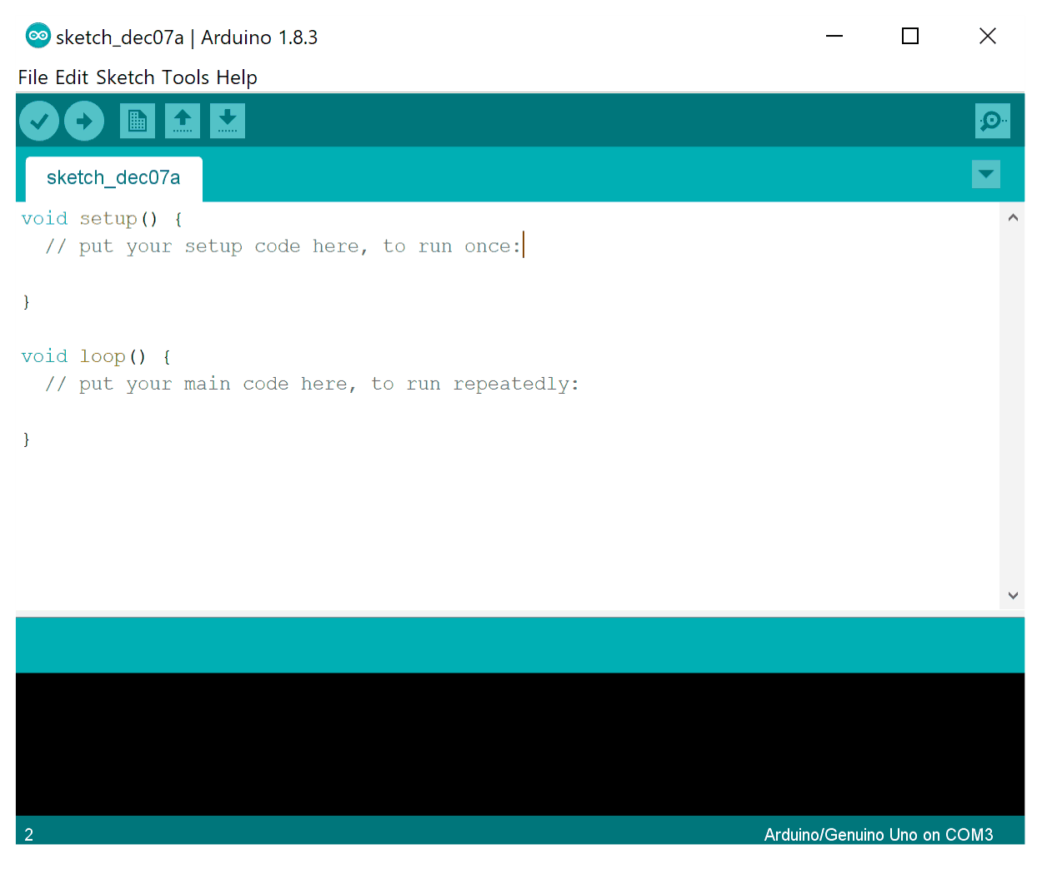

1. Connect USB to Arduino Board
2. Set baud rate 9600 at Serial Monitor output.

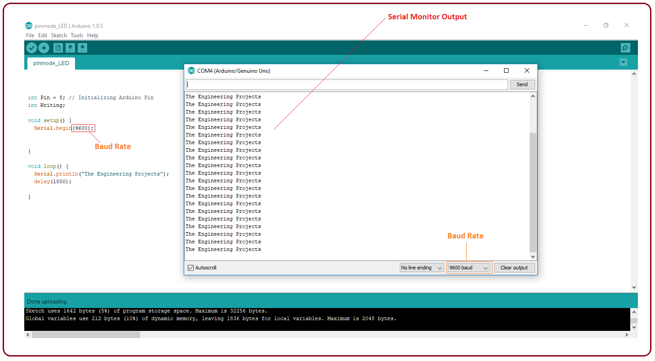

Testing

1. Power up the GSM module with sim card (better use limited sim card to avoid over usage if error)
2. “NWK“ LED blinking fast at GSM module means it searching network. Wait it not blinking before proceed.
3. Run code using Arduino IDE.
4. Clicked button.
5. A message “Button pushed down” is written at Arduino serial monitor output.
6. Message is sent to phone.

( You can change the message text at message value, and number of PIC at mobileNumber value)

1. A message “Message is sent."” is written at serial monitor output.
2. If the button is still pushed without release, the message will be triggered again after 5 minutes

(You can change the delay at SmsDelay value)

1. If the button is release and push, the message should be trigger after 5 minutes too.
2. You can change instead of sending message to trigger a ghost call by replacing “send_message();” inside void loop() to “make_call();”.
3. A ghost call will be trigger to the number that will last 8 seconds with 5 minutes delay same as message.
4. No need to reset. It always standby when button is release.

Disclaimer

Sorry, never test. But should work.